Diet residence in digestive tract: ECB

The purpose of this study will be to determine the amount of time diet remains in the digestive tract of ECB in diapausing and non diapausing UZ strain larvae. With this information we can estimate digestion time across the 5th instar (an important piece of information when conducting bioassays for wandering larvae).

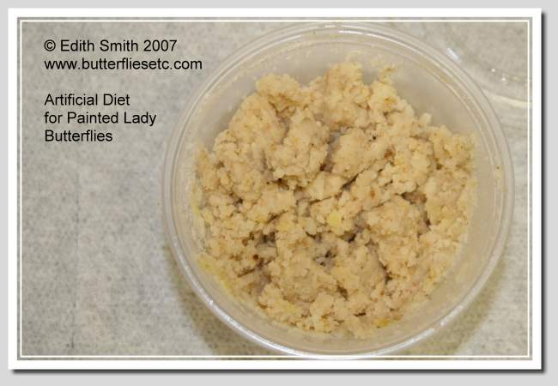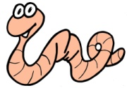

**?Time to frass?**